**INTRODUCTION TO DATA MANAGEMENT PROJECT REPORT**

(Project Semester August-December 2020)

***CALL DATA ANALYSIS***

Submitted by

Shivdutt Dixit

Registration No.: 1802597

Programme: P192-ND Integrated B.Tech-M.Tech CSE

Section: KM080

Course Code: INT217.

Under the Guidance of

**Maneet Kaur, 15709**

**Assistant Professor**

**Discipline of CSE/IT**

**Lovely School of Computer Science and Engineering**

**Lovely Professional University, Phagwara**



# CERTIFICATE

This is to certify that Shivdutt Dixit bearing Registration no. 11802597 has completed INT217 project titled, **“Call Data Analysis”** under my guidance and supervision. To the best of my knowledge, the present work is the result of his/her original development, effort, and study.

**Maneet Kaur**

**Assistant Professor**

**School of Computer Science and Engineering**

Lovely Professional University

Phagwara, Punjab.

Date: 17-12-2020

# DECLARATION

I, Shivdutt Dixit student of Integrated B.Tech-M.Tech under CSE/IT Discipline at, Lovely Professional University, Punjab, hereby declare that all the information furnished in this project report is based on my own intensive work and is genuine.

Date: 17-12-2020

Registration No. 11802597 Shivdutt Dixit

**Table of Content**

**S.No Title Page No.**

1. Certificate 2
2. Declaration 3
3. Introduction 5
4. Objective of Analysis 5
5. Source of dataset 5
6. ETL Process 5
7. Analysis 1: Call quality of operators between different states 6
8. Analysis 2: Call quality review of operators for different conditions 9
9. Analysis 3: Network type analysis of operators 12
10. Analysis 4: Rating-wise analysis of different operators 15
11. Analysis 5: State-wise analysis of different network coverage 16
12. References 18

# Introduction:

TRAI provides customers feedback captured using TRAI MyCall App. Customers rates their experience about voice call quality in real time and help TRAI gather customer experience data along with Network data. This helps analysts determine the quality of different networks and the services provided by different network providers along different terrains, geographical conditions, network type and coverage along the country based on the customer rating feedback. The rating is done on a scale of 1 to 5. Based on the feedback received TRAI governs the regulations for telecom providers.

# Objective of analysis:

The main objective of the analysis is to compare the quality of voice call that customers experience for major telecom operators across the country and for various network coverage in different conditions for the month of May, June, July, and August from the data feedback provided by various customers on TRAI MyCall app which is uploaded on data.gov.in . The primary objectives include the analysis of:

* Call quality of operators between different states
* Call quality review of operators for different conditions
* Network type analysis of operators
* Rating-wise analysis of different operators
* State-wise analysis of different network coverage

# Source of dataset:

<https://data.gov.in/catalog/voice-call-quality-customer-experience?filters%5Bfield_catalog_reference%5D=3995421&format=json&offset=0&limit=6&sort%5Bcreated%5D=desc>

# ETL Process:

The **E**xtraction of the data has been done from the data.gov.in website wherein the catalog for Telecom Regulation Authority of India (TRAI) provides the Customer Voice Call Experience dataset for different months.

The dataset has then been **T**ransformed into a consistent system using Tableau Prep, a data cleaning software, and the flow for the same is given below:

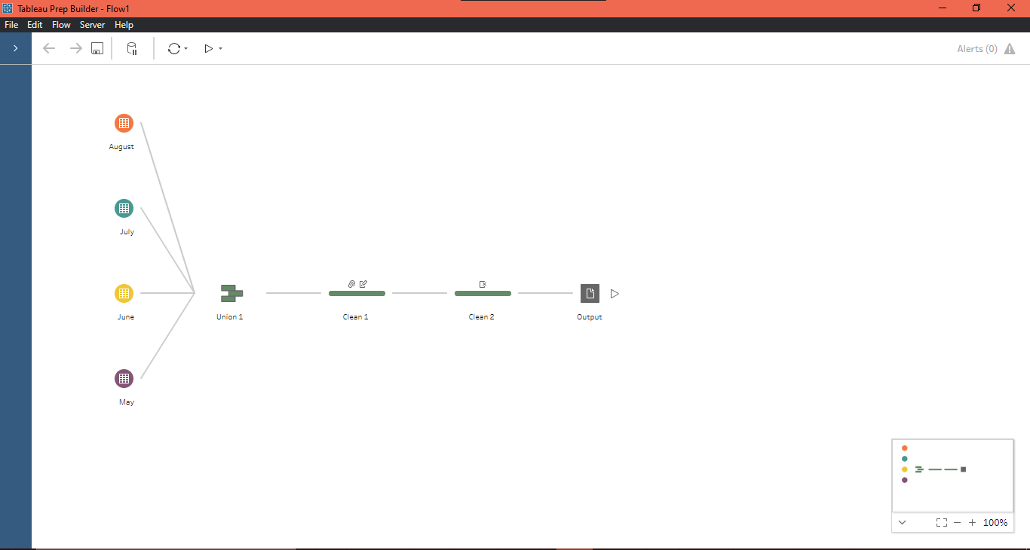**Figure 1:** Tableau Prep Flow

Once the dataset has been transformed into a consistent system and necessary changes have been made into it, the dataset is finally **L**oaded into a csv file and further analysis has been made on the final csv file using MS Excel.

# Analysis 1: Call quality of operators between different states

1. **Introduction:** In this analysis the quality of call for different operators in different states has been compared.
2. **General Description:** For each operator, the call quality has been divided in three categories namely Call Dropped, Poor Voice Quality, and Satisfactory. The analysis has further been broken into operator-wise analysis for states.
3. **Analysis Results:** It has been observed from the analysis that Maharashtra has maximum number of Call Drops for all the operators, Airtel and Idea have maximum number of Poor Voice Quality Reviews, and RJio provides maximum number of Satisfactory Calls.
4. **Visualizations:**

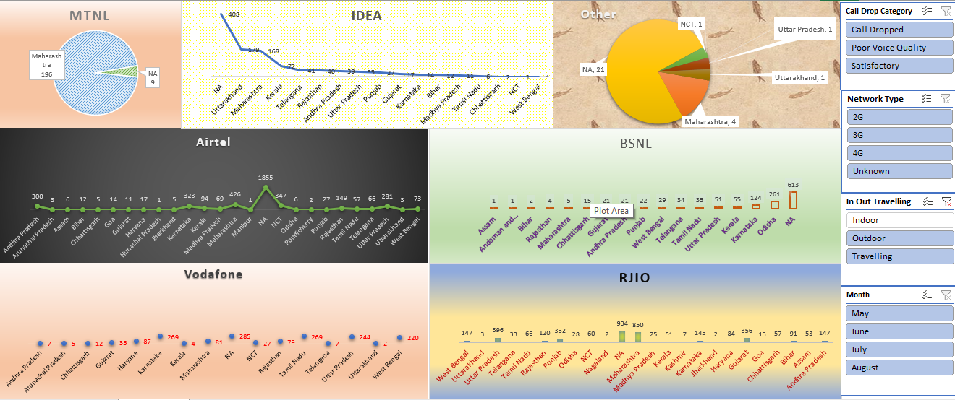 **Figure 2**: Dashboard of Analysis 1

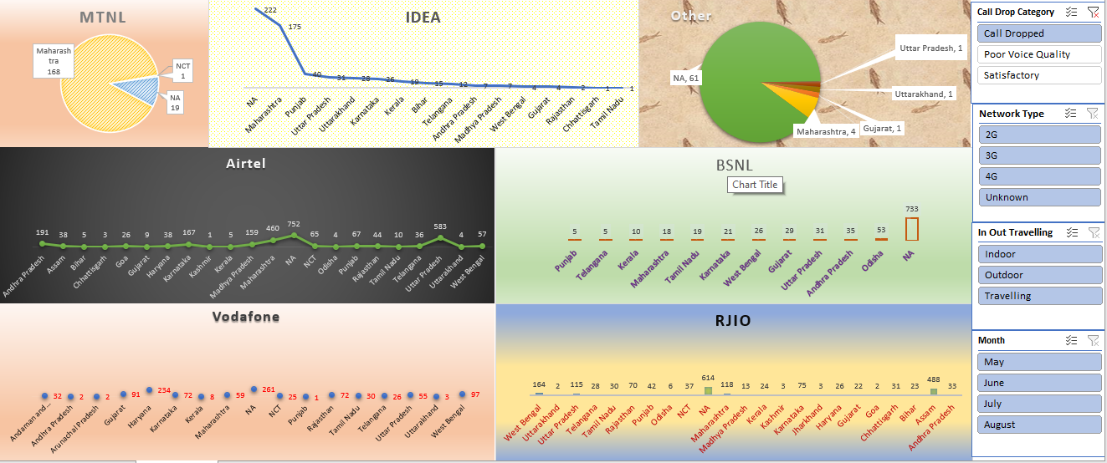 **Figure 3**: Call Dropped Analysis of Operators

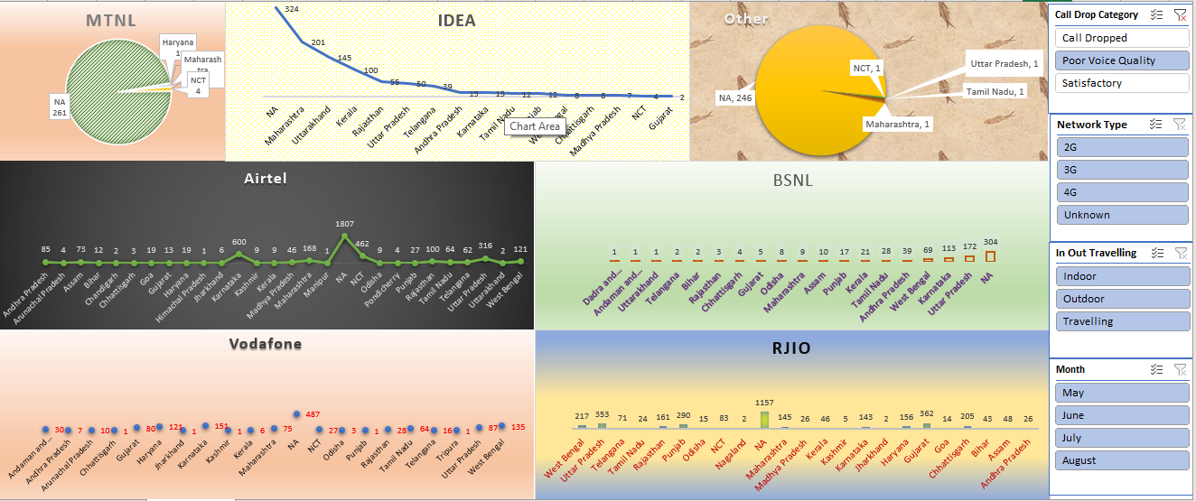 **Figure 4**: Poor Voice Quality Analysis

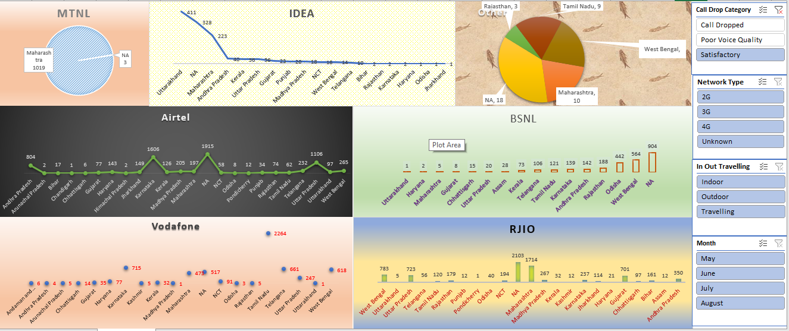 **Figure 5:** Satisfactory call Analysis

# Analysis 2: Call quality review of operators for different conditions

1. **Introduction:** In this analysis the quality of call for different operators for different geographical conditions has been compared.
2. **General Description:** For the geographical conditions, the call quality has been divided into ratings of 1 to 5. The analysis has further been broken into condition-wise analysis for operators.
3. **Analysis Results:** It has been observed from the analysis that Airtel has worst outdoor coverage travelling coverage but mixed indoor coverage, RJio has best and worst indoor coverage, Idea has average quality of call, and BSNL and Vodafone provides very good overall coverage.
4. **Visualizations:**

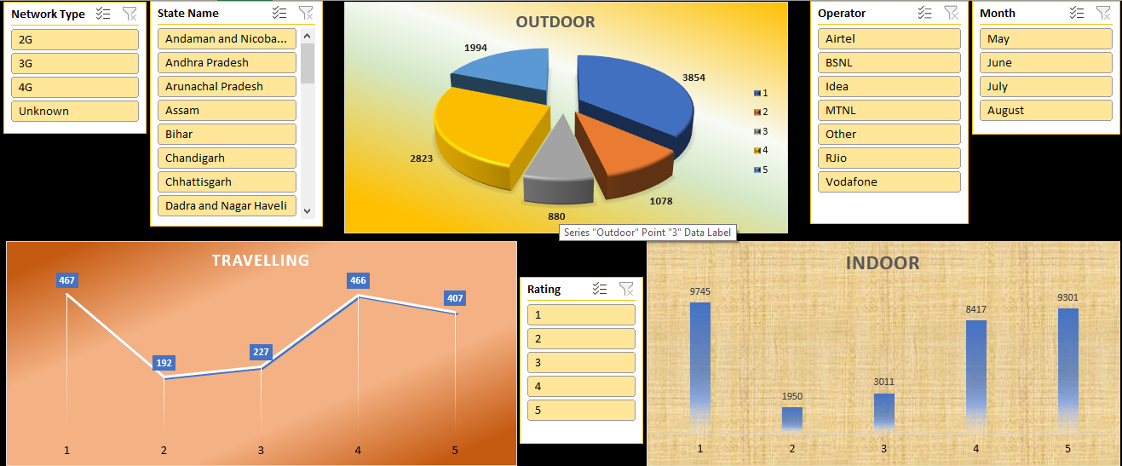**Figure 6:** Dashboard of Analysis 2

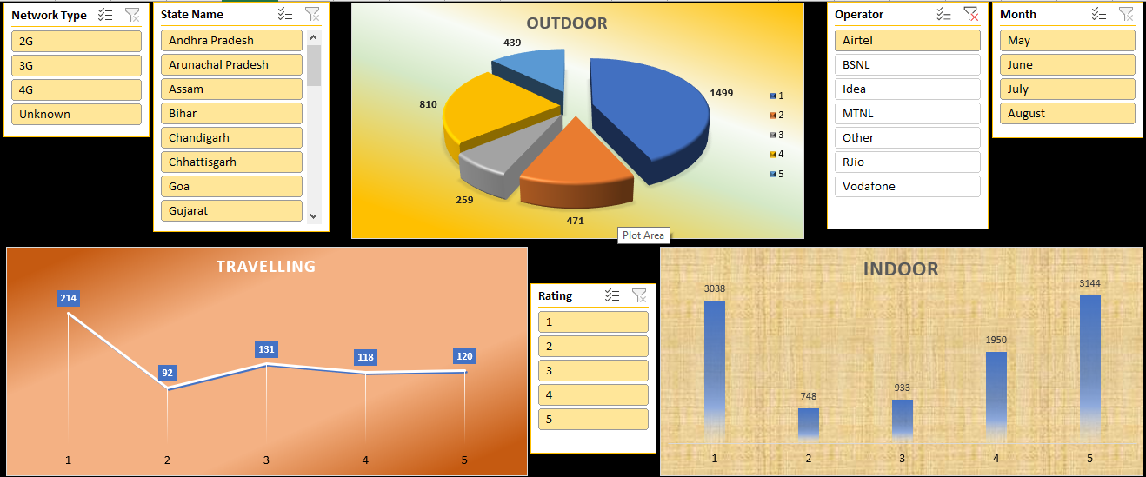**Figure 7:** Airtel

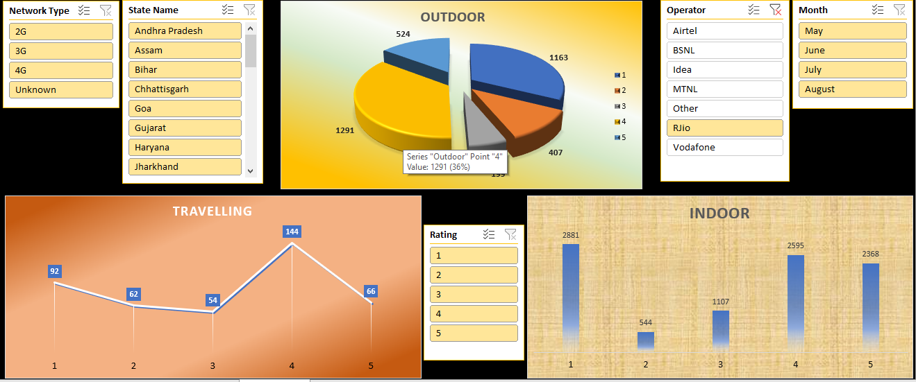 **Figure 8:** RJio

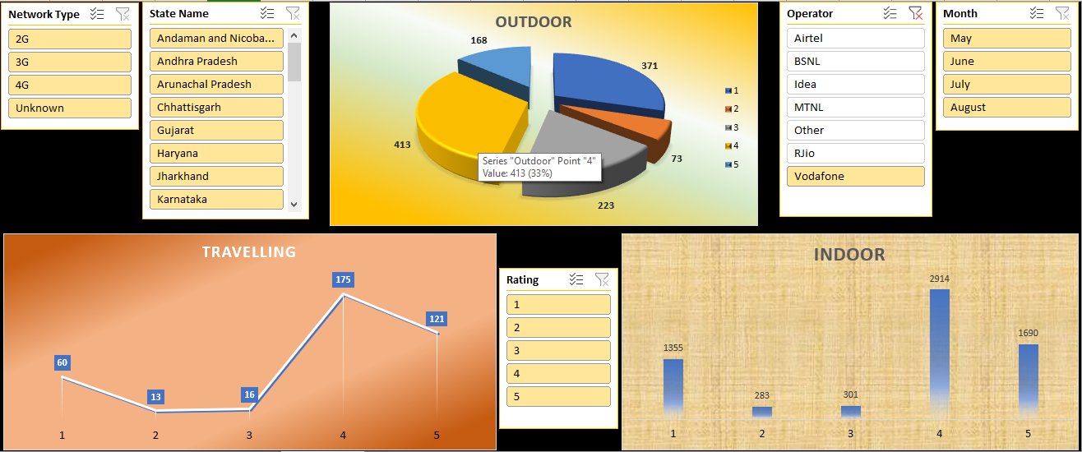 **Figure 9:** Vodafone

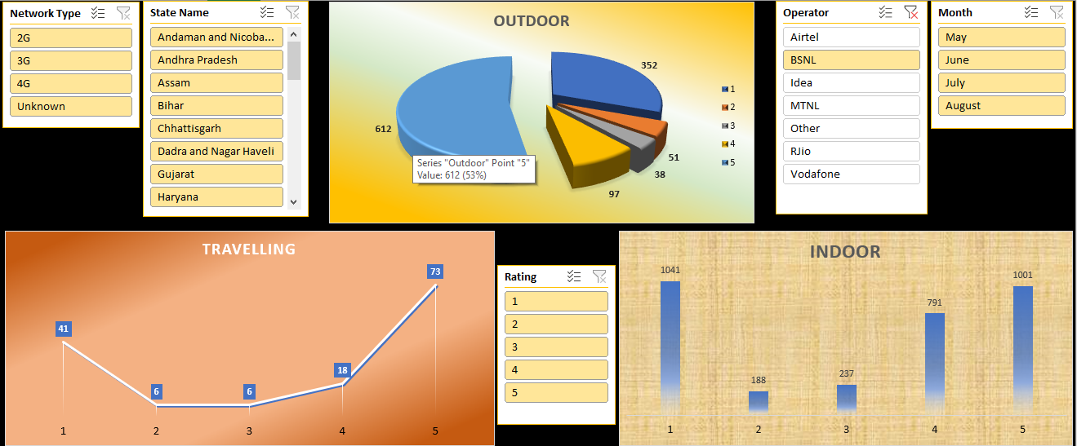 **Figure 10:** BSNL

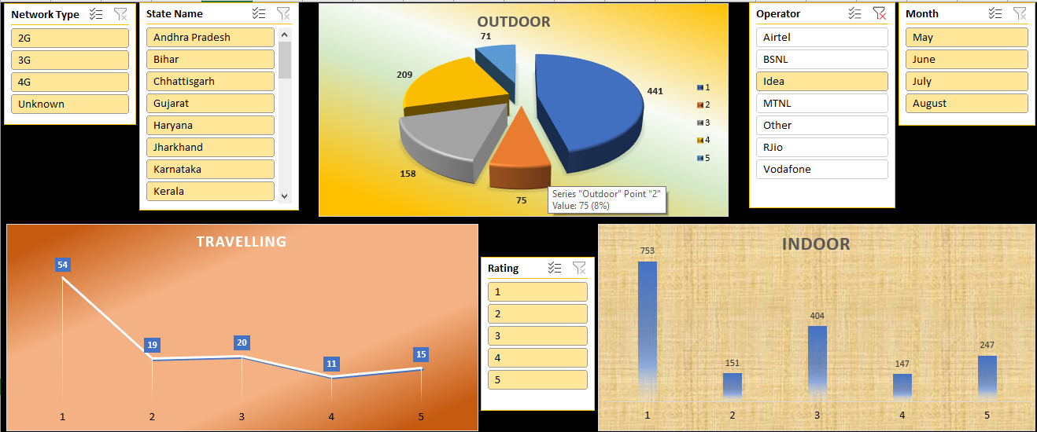 **Figure 11:** Idea

# Analysis 3: Network type analysis of operators

1. **Introduction:** In this analysis the quality of call for different operators for different network types has been compared.
2. **General Description:** For the operators, the call quality has been divided into three categories namely Call Dropped, Poor Voice Quality, and Satisfactory. The analysis has further been broken into network-wise analysis for operators.
3. **Analysis Results:** It has been observed from the analysis that Airtel has maximum number of call drops in 2G, 4G and Unknown network types while BSNL has maximum call drops for 3G network. Furthermore, Airtel has poor call quality in 2G and Unknown network whereas Vodafone and RJio respectively have poor call quality in 3G and 4G. Also, Vodafone provides maximum satisfactory calls in 2G and 3G network while RJio in 4G and Airtel in Unknown network have most satisfactory calls.
4. **Visualizations :**

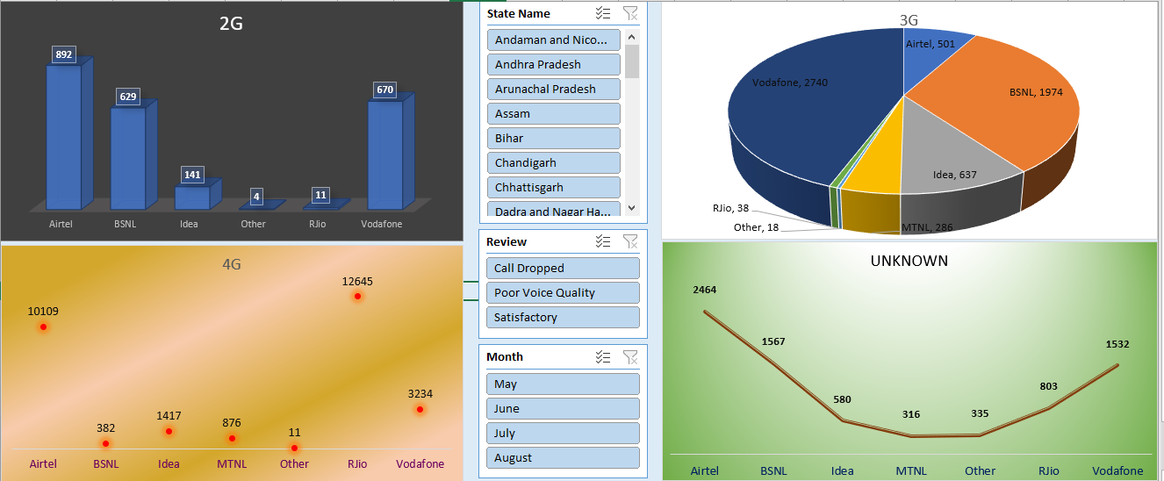**Figure 12:** Dashboard of Analysis 3

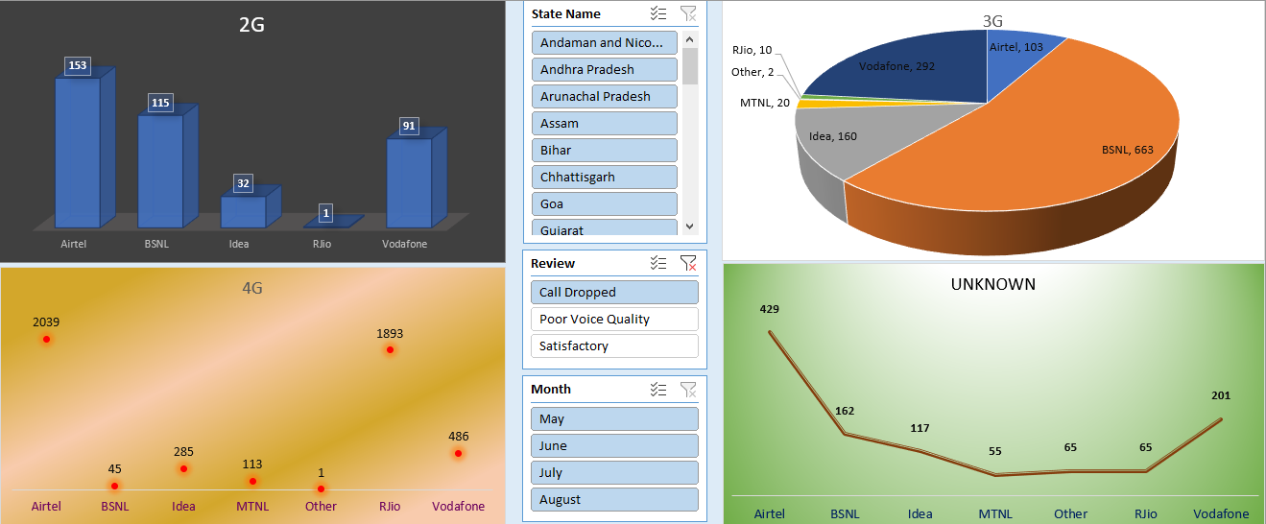 **Figure 13:** Call Dropped

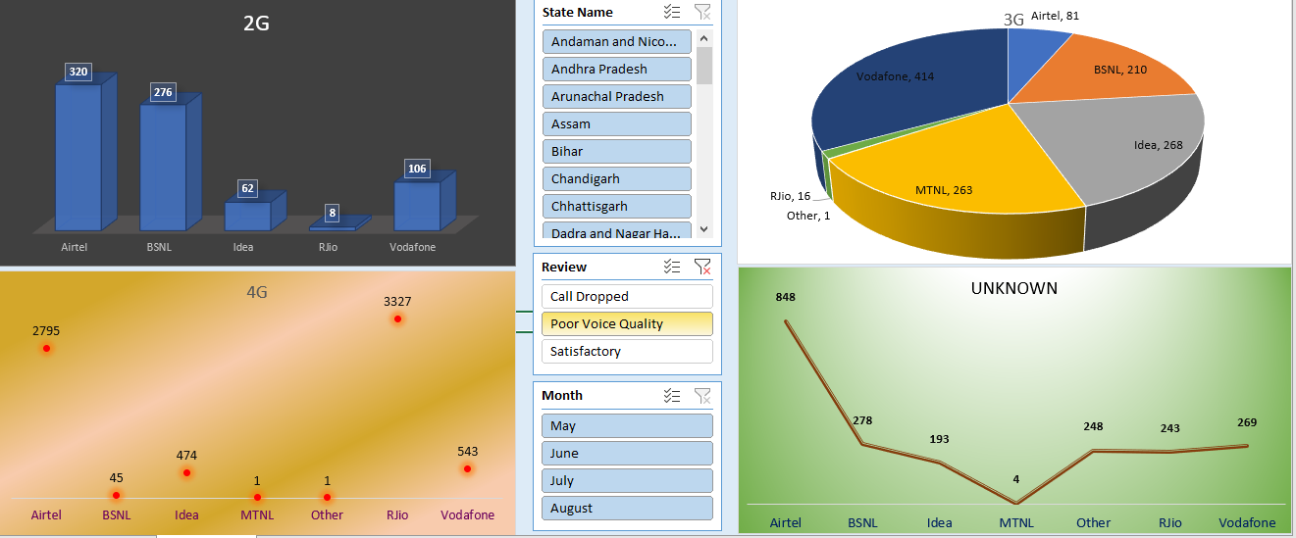 **Figure 14:** Poor Voice Quality

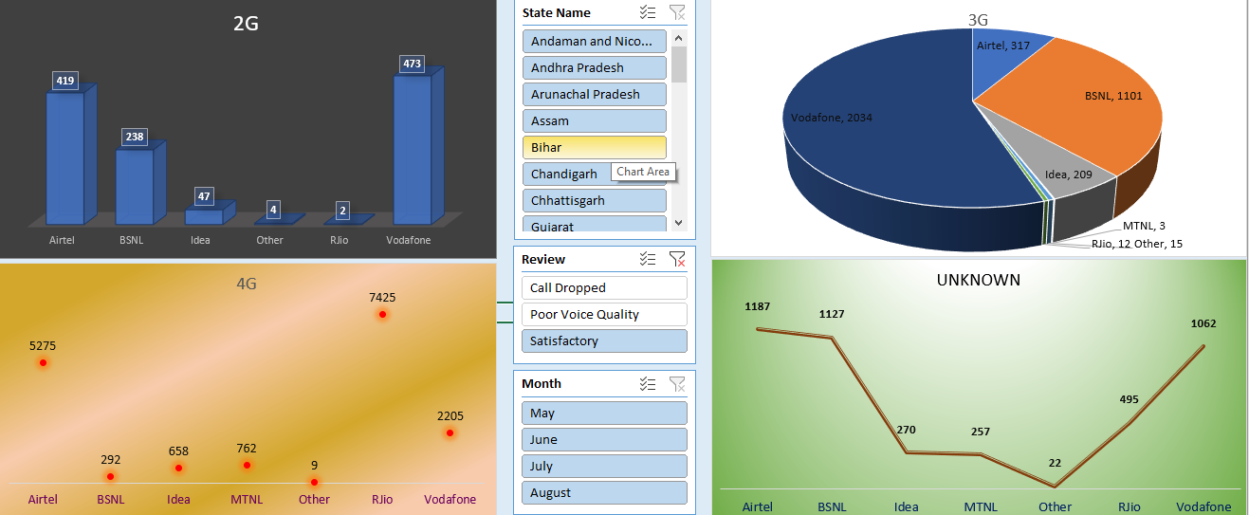**Figure 15:** Satisfactory

# Analysis 4: Rating-wise analysis of different operators

1. **Introduction:** In this analysis the quality of call for different operators for different ratings has been compared.
2. **General Description:** For the operators, the call quality has been divided into five ratings i.e., 1 to 5. The analysis has further been broken into rating-wise analysis for operators.
3. **Analysis Results:** It has been observed from the analysis that Airtel has received maximum number of 1, 2, and 5 rating whereas RJio has maximum number of 2 and 3 ratings. From the analysis, it can be clearly seen that Airtel and RJio have received overall maximum rating and Idea has least number of overall ratings in major telecom service providers in the country.
4. **Visualizations :**

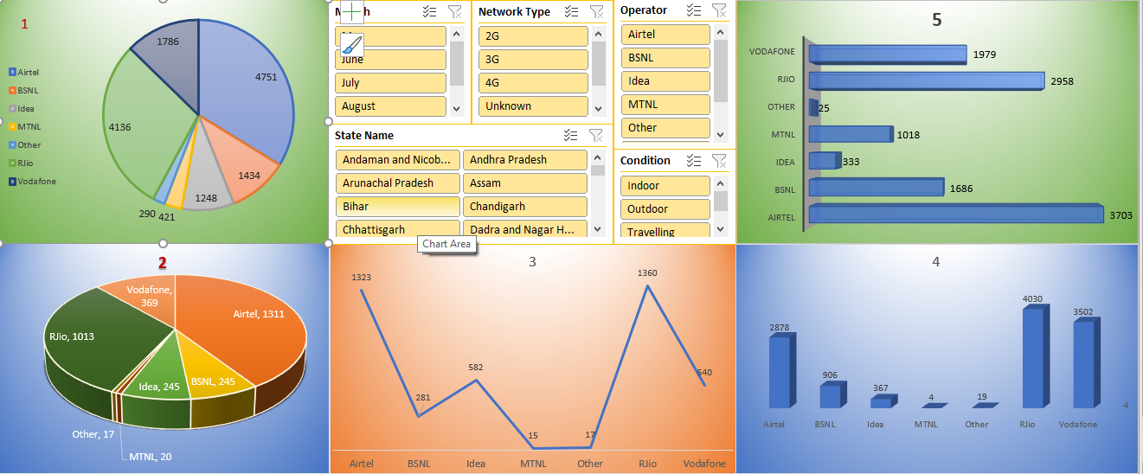 **Figure 16:** Dashboard of Analysis 4

# Analysis 5: State-wise analysis of different network coverage

1. **Introduction:** In this analysis the quality of call for different network coverage of different network types across the country have been compared.
2. **General Description:** For the operators, the call quality has been divided into three groups namely Indoor, Outdoor and Travelling for which coverage of different network types has been compared. The analysis has further been broken into condition-wise analysis for operators.
3. **Analysis Results:** It has been observed from the analysis that if data for unspecified state name is excluded then Maharashtra has best overall indoor and outdoor coverage meanwhile Uttar Pradesh has best overall travelling coverage. Also, Uttar Pradesh suffers maximum call drop for indoor and travelling and Maharashtra for outdoor. Customers of Tamil Nadu and Karnataka have most satisfactory calls indoor, Karnataka for Travelling and Maharashtra for Outdoor.
4. **Visualizations:**

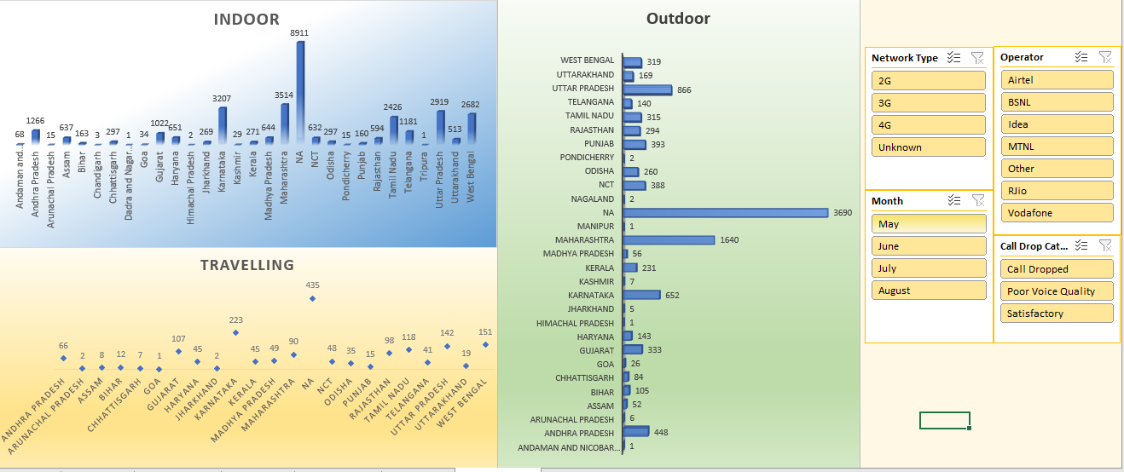**Figure 17:** Dashboard of Analysis 5

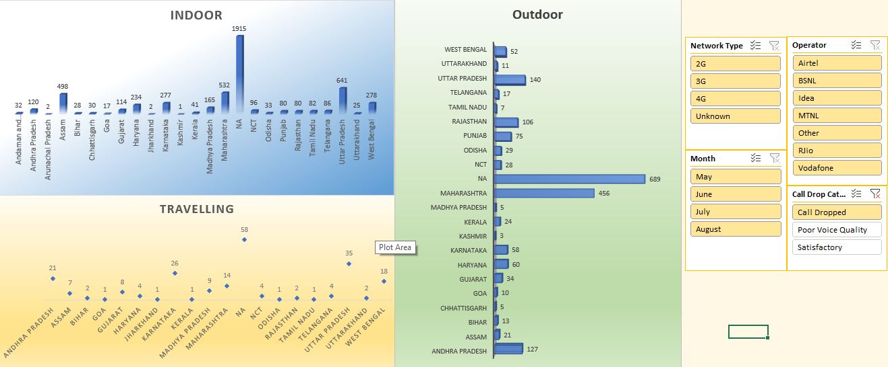 **Figure 18:** Call Drop

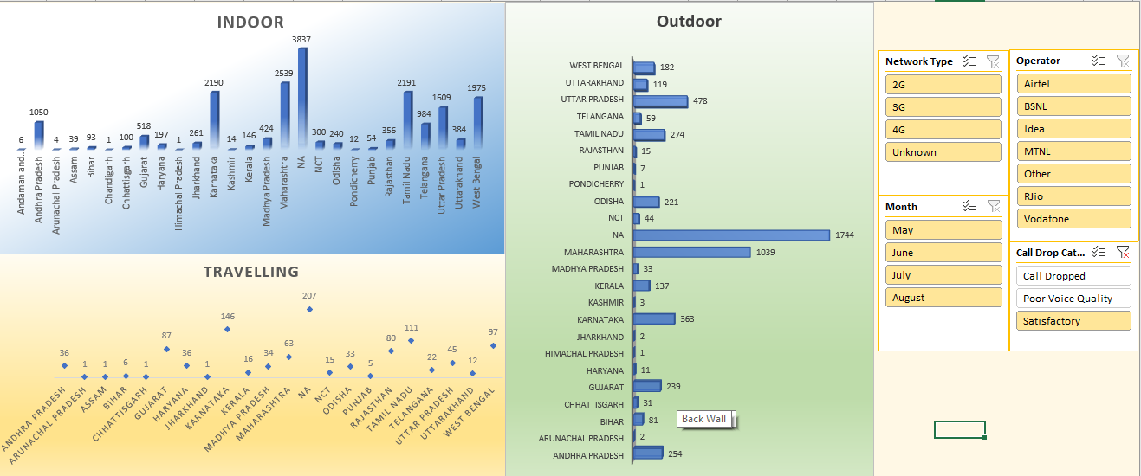 **Figure 19:** Satisfactory

# References

* <https://data.gov.in/>
* <https://trai.gov.in/consumer-info/telecom/service-provider-list>
* <https://en.wikipedia.org/wiki/List_of_telecom_companies_in_India>
* <https://analytics.trai.gov.in/>
* <https://trai.gov.in/mycall-dashboard>